# **Process Configuration Document**

* Download Microsoft ODBC Driver for SQL Server from following link <https://www.microsoft.com/en-us/download/details.aspx?id=53339>
* After installation open Microsoft ODBC application

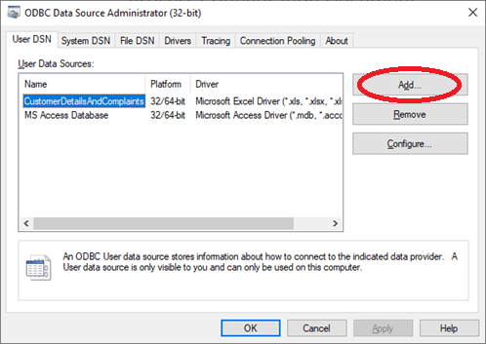

* Click on Add button to create a new data source.

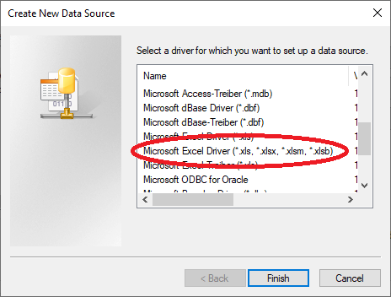

* Select **Microsoft Excel Driver** and click **Finish** button.

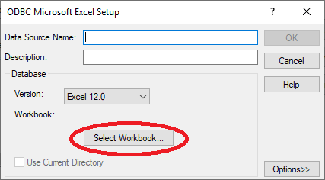

* Enter new **Data Source Name** and click **Select Workbook** buttonto select the excel

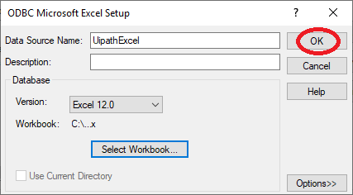

* Finally click **OK** button to finish new configuration.